User Guide
Using the ESP32 Study Manager
The ESP32 Study Manager turns a Job Traveler PDF into a time study stored on your ESP32 device, lets you review recorded studies, and exports them to Excel. This guide walks through the four tabs — Home, Create Study, Current Studies, and Export — in the order you’ll normally use them.
Before you start
Connect the ESP32 to your computer with a USB cable before opening the app. If Windows doesn’t recognize the device, install the CP210x driver first (see the Driver Setup Guide).

1. Home — check your connection
The Home tab confirms the app can see your device. A green dot reading Connected — COMx means you’re ready to go. The Device Information panel shows the port, USB device, manufacturer, how many studies are stored, and the baud rate. If you plug in the ESP32 after opening the app, click Refresh Device.
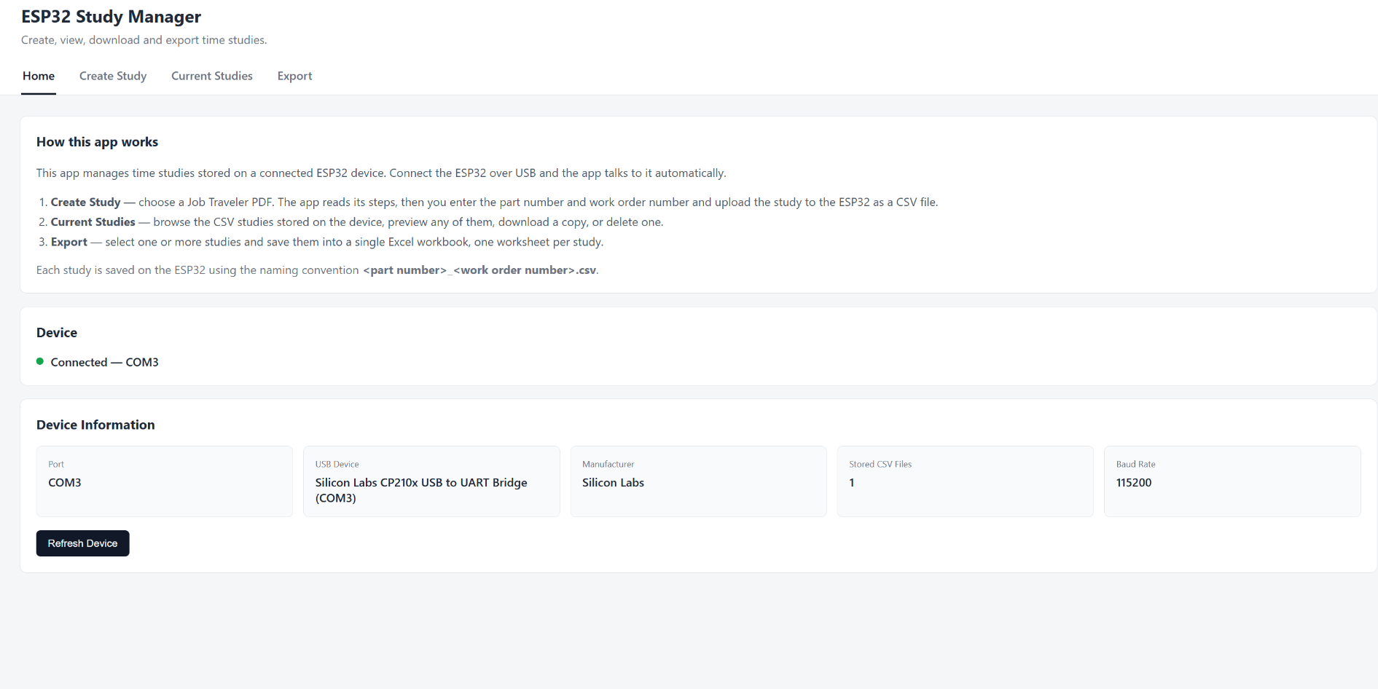
The Home tab, showing a connected device and its details.
2. Create Study — build a study from a PDF
Open the Create Study tab and click Choose JT PDF to select a Job Traveler PDF. The app reads the steps directly from the document.
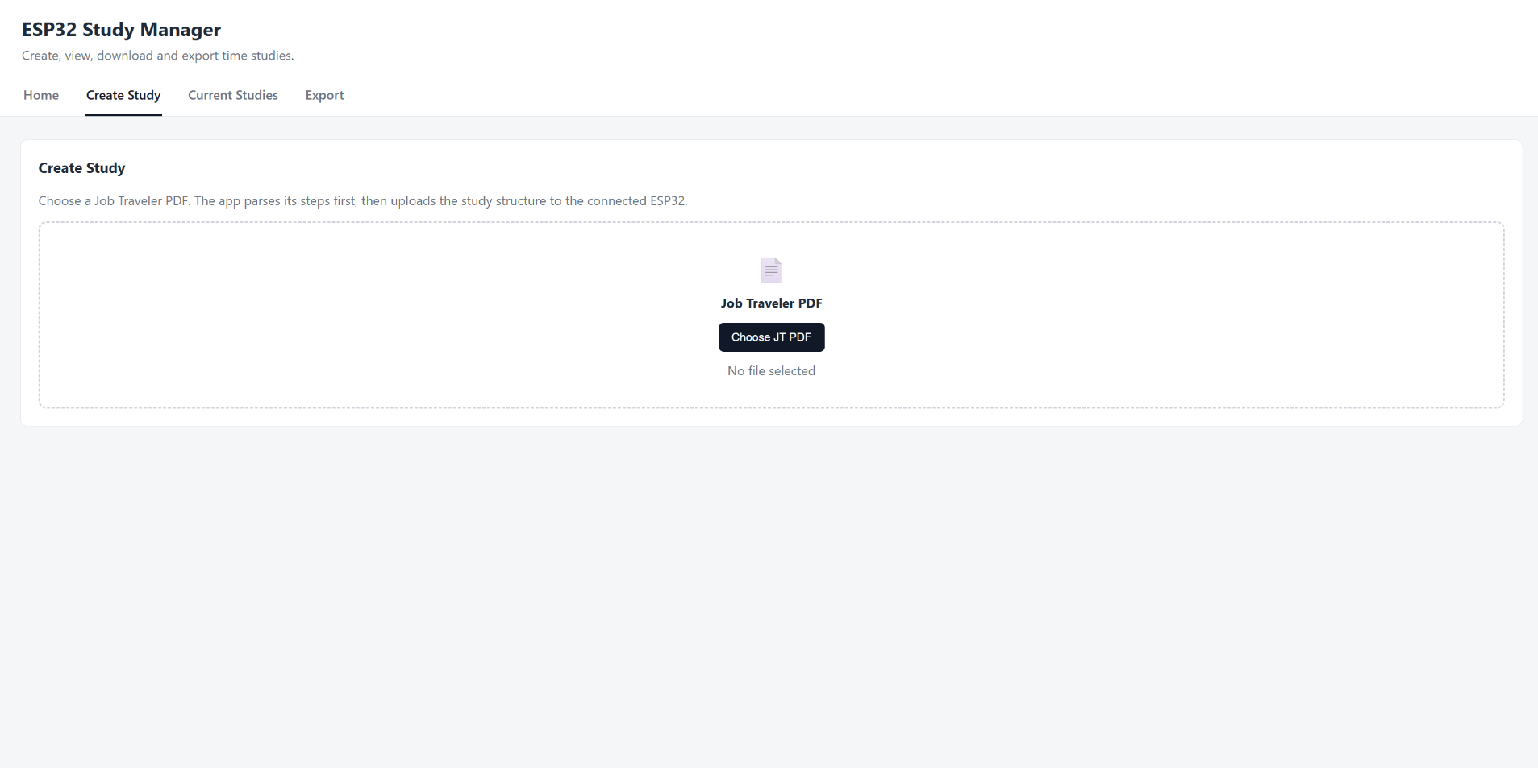
The Create Study tab before a PDF is chosen.
Once the PDF is parsed, fill in the required Part number and Work order number. Together these name the study on the device as <part>_<WO>.csv. You can optionally set a Custom name to override that. Review the parsed steps below: click any description to edit it, use the ↑ / ↓ arrows to reorder, ✕ to remove a step, or + Add Step to insert one. When it all looks right, click Create Study on ESP32.
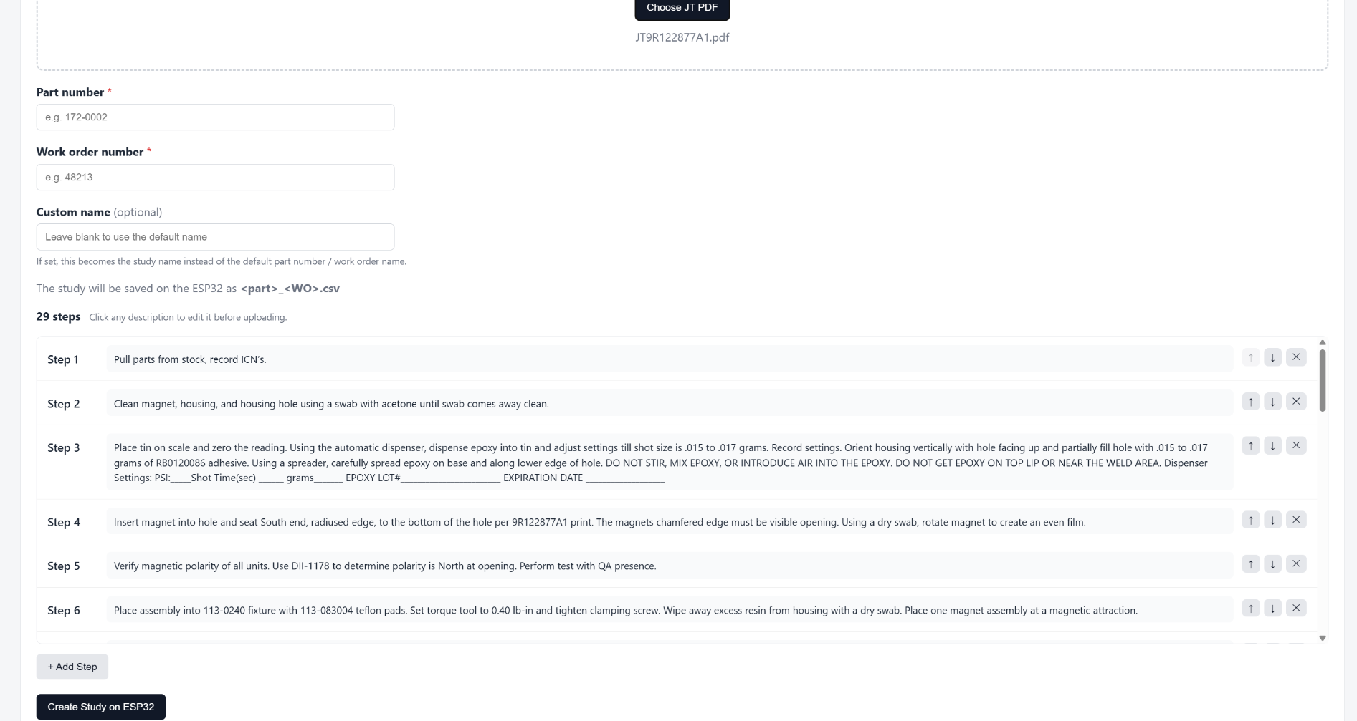
Filling in the details and editing parsed steps before uploading.
3. Current Studies — review and manage
The Current Studies tab lists every study stored on the ESP32. Select one to preview its steps alongside the recorded times (mm:ss). Use Download CSV to save a copy to your computer. The Delete File panel removes a study from the device permanently — it asks for two confirmations and cannot be undone.
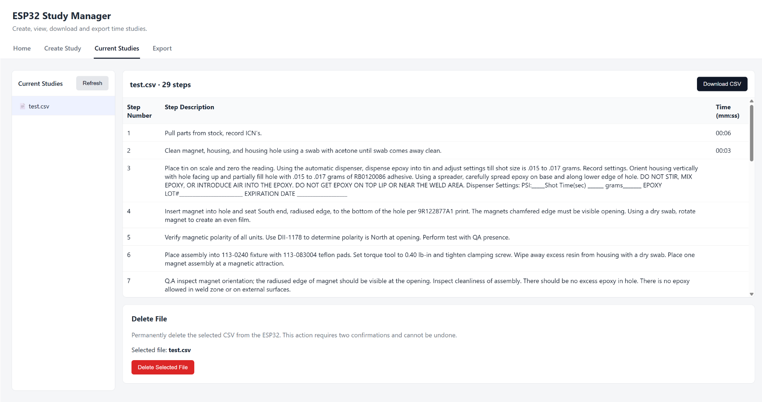
Previewing a stored study with its recorded step times.
4. Export — save studies to Excel
The Export tab turns studies into a single Excel workbook. Check the studies you want (or use Select all), click Export Excel, and choose where to save. Each study becomes its own worksheet, with step numbers, descriptions, and times.
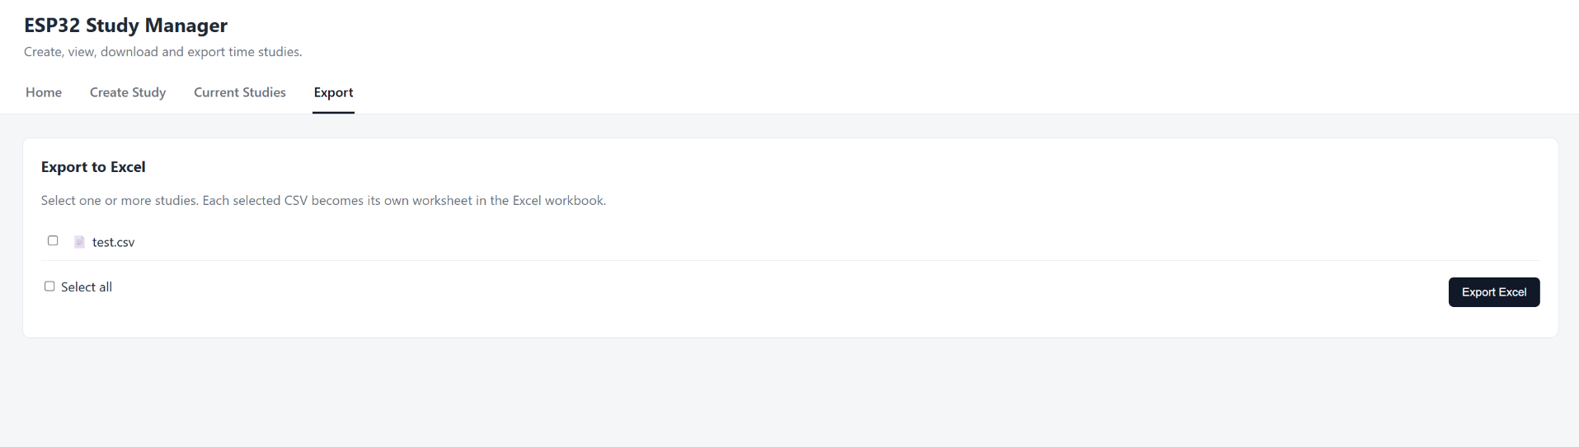
The Export tab, ready to save selected studies to Excel.
Tip
Because every study is named by part and work order number, exported workbooks are easy to match back to the job they came from.

